Subject Pronouns

In Spanish, sentences often start with a subject pronoun. Subject pronouns are used to tell who is doing the action in a sentence.

Subject pronouns | English translation
Yo | I
Tú | You (familiar)
Usted | You (formal)
Él | He
Ella | She
Nosotros | We (masculine)  (Used if there is one or males in a group)
Nosotras | We (feminine)  (Used if there are only females in a group)
Ustedes | You (pl) (You guys)
Ellos | They (masculine)  (at least one male in group)
Ellas | They (feminine)  (only females)

Abbreviations

Sometimes usted and ustedes are abbreviated.

Usted Ud. Ustedes Uds.

Matching. Please match the Spanish words below with their English translations. Write the corresponding number on the line.

________ ella 1. I
________ ellas 2. you (familiar)
________ ellos 3. you (formal)
________ él 4. we (masculine)
________ nosotros 5. she
________ nosotras 6. he
________ usted 7. we (feminine)
________ yo 8. they (masculine)
________ tú 9. they (feminine)
________ ustedes 10. you (pl) (you guys)

Pretend you are Spongebob. What subject pronoun would you use to talk about these people? (yo, él, ella, nosotros, nosotras, ellos, ellas)

____________________

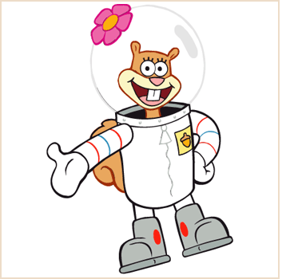

____________________

____________________

____________________

____________________

Pretend you are Spongebob. What subject pronoun would you use to talk to these people? (tú, usted, ustedes)

____________________

____________________

____________________

____________________

------------------------------------------------------------------------------------------------------------

ANSWER KEY

Matching. Please match the Spanish words below with their English translations. Write the corresponding number on the line.

5 ella 1. I
9 ellas 2. you (familiar)
8 ellos 3. you (formal)
6 él 4. we (masculine)
4 nosotros 5. she
7 nosotras 6. he
3 usted 7. we (feminine)
1 yo 8. they (masculine)
2 tú 9. they (feminine)
10 ustedes 10. you (pl) (you guys)

Pretend you are Spongebob. What subject pronoun would you use to talk about these people? (yo, él, ella, nosotros, nosotras, ellos, ellas)

_______YO_____

____ELLA___

___ELLOS_

___ÉL_______

___NOSOTROS_____

Pretend you are Spongebob. What subject pronoun would you use to talk to these people? (tú, usted, ustedes)

USTEDES

TÚ

TÚ

USTED

