Assignment #7
¡Qué desastre!
Your classroom is a mess! Complete the sentences below to describe where the items are located in the classroom pictured below.
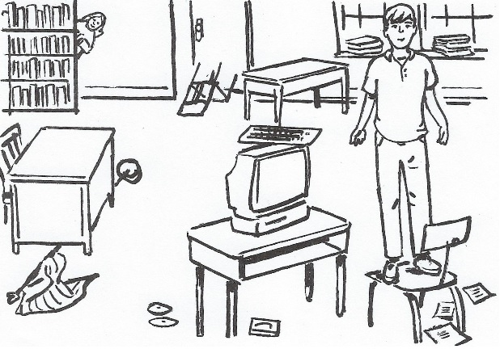

Ex) El chico está encima de la silla.
- La bandera
- El teclado
- La puerta
- La pantalla
- Las hojas de papel
- Los disquetes

