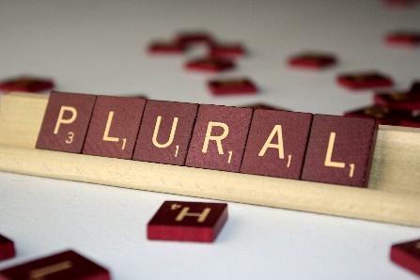
El Plural

*It is easy to make objects in Spanish plural!

1) If the object ends in a vowel, add -S

2) If the object ends in a consonant, add -ES

- Write the following vocabulary words in the plural form. Ex) libro libros

  - puerta ________________________________
  - ventana ________________________________
  - reloj ________________________________
  - cartel ________________________________
  - pupitre ________________________________

(Answers: 1. Puertas, 2. Ventanas, 3. Relojes, 4. Carteles, 5. Pupitres)

Exceptions: 1. Words that already end in -S do not change. (un sacapuntas, dos sacapuntas)

2. Words that end in -Z, change the Z to C before
adding -ES.
(un lápiz, dos lápices)

- Plural articles

The article in front of a word also changes when a word becomes plural.

To say “THE” in Spanish:
 | Singular | Plural
Masculine | EL | LOS
Feminine | LA | LAS

Ex) The computer = La computadora

The computers = Las computadoras

Write the following words in the plural form. Ex) el libro los libros

  - La mesa ________________________________
  - La ventana ________________________________
  - El reloj ________________________________
  - El cartel ________________________________
  - El lápiz ________________________________
(Answers: 1. Las mesas, 2. Las ventanas, 3. Los relojes, 4. Los carteles, 5. Los lápices)

UN/ UNA

Un/ Una = a / an

In Spanish, the articles un and una change in the plural form.

Un unos
Una unas

Unos / Unas means some/ a few

Ex) una silla unas sillas
A chair some chairs

Write the following words in the plural form. Ex) un libro unos libros

- Una mochila ________________________________
- Un ratón ________________________________
- Una pantalla ________________________________
- Un cartel ________________________________
- Un sacapuntas ________________________________
(Answers: 1. Unas mochilas, 2. Unos ratones, 3. Unas pantallas, 4. Unos carteles, 5. Unos sacapuntas)

How would you say…

Some flags: __________________________

Some windows: __________________________

The chairs: ___________________________

The keyboards: ____________________________

(Answers: unas banderas, unas ventanas, las sillas, los teclados)

